AGENDA

**FREDERICK**

**COUNTY**

**Domestic Violence Coordinating Council**

April 2, 2025

SAO | Judiciary | Heartly House | FCSO | FPD | FHH| DSS | FCHD | P&P | FCPS | CAC | Public Members



COUNCIL MEMBERSHIP

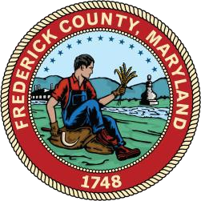

**DVCC MEETING AGENDA**

1. Call to Order/Establishment of Quorum—Brett Engler, Chairperson

1. Approval of Minutes
2. Old Business/Agency Updates
3. Family Justice Center Update/Strangulation Protocol
4. Committee Reports:
5. Victim Services:
6. Legislative:

* Brett Engler (SAO) Chair
  + 2025 Legislative Session
    - Marital Communications Privilege
    - Forfeiture by Wrongdoing--Misdemeanors

1. Offender Programming:
2. Community Engagement:
   * Jay Hessler
3. Justice Response:
   * Maggie Henderson (FCSO) Co-Chair

VI. Public Comments

VII. Council Member Comments

* Next meeting July 2, 2025

VIII. Adjournment

**Please keep in mind the Frederick County Domestic Violence Coordinating Council is subject to the Open Meetings Act requiring reasonable advance notice of meetings be provided, to make the agenda available in advance, to hold its meetings openly, and to adopt and retain minutes.** **The group is also subject to the Public Information Act, meaning any member of the public may request any record pertaining to the work group at any time.**