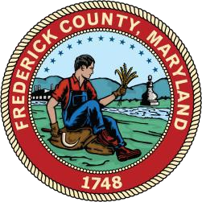
AGENDA

FREDERICK

COUNTY

Domestic Violence Coordinating Council

January 5, 2022

5
PM

SAO | Judiciary | Heartly House | FCSO | FPD | FHH| DSS | FCHD | P&P | FCPS | CAC | Public Members

COUNCIL MEMBERSHIP

DVCC MEETING AGENDA
- Call to Order/Establishment of Quorum—Brett Engler, Chairperson

- Approval of Minutes of December 8th, 2021

- Old Business
  - Email Ellen Byrne
  - Agency Updates

- Agency Presentation: Jay Hessler, Frederick County Health Department

- Agency Presentation: Dr. Suzy Boisclair, Frederick Police Department

- Appointment of Subcommittee Chairs

- Committee Reports
  - Victim Services
  - Offender Programming
  - Legislative
  - Community Engagement

- Future Domestic Violence Coordinating Council Meeting Dates and Times—
  - February 2, 2022
- VI. Public Comments
a. Public comments for the Domestic Violence Coordinating Council meetings will be accepted on the public portal at https://www.publicinput.com/R2728 or by calling toll-free 855-9252801, enter meeting code 4455 to listen to the meeting. To give public comment press *3 during that portion of the meeting.

VII. Council Member Comments

VIII. Adjournment
Please keep in mind the Frederick County Domestic Violence Coordinating Council is subject to the Open Meetings Act requiring reasonable advance notice of meetings be provided, to make the agenda available in advance, to hold its meetings openly, and to adopt and retain minutes. The group is also subject to the Public Information Act, meaning any member of the public may request any record pertaining to the work group at any time.

